Intent:
The intent of this evaluation is to review the storm water management plans in Los Angeles County and consider how they overlap with the goal of understanding, and being able to place in perspective, the role of the earthbottom channel maintenance WDR. The focus of the evaluation is on storm water management plans in regards to flood control and the volumes of stormwater which reaches rivers and streams. Plans which concentrate on water supply, water recycling, or water quality are not a focus of this evaluation.

Conclusions:
The stormwater management drivers:
The two significant drivers in terms of shaping the future of stormwater management appear to be the GLAC IRWMP and the EWMPS and WMPs. A third document, the Basin Study, may become a significant driver of change to stormwater management if, and how, it is implemented. The GLAC IRWMP is significant because it is very comprehensive and includes broad targets although it does not commit to specific projects. The EWMPS and WMPs are significant because they include specific projects with timelines or plans to develop specific projects with timelines. Considered as a group, the EWMPS and WMPs are comprehensive. The EWMPs WMPs have generally been coordinated with the IRWMP.

Important plans but not drivers:
Other watershed plans like the City of LA SCMP and the watershed specific plans are smaller in scope, less proscriptive or overlap with the more significant plans. The sediment-related plans (Sediment Management Strategic Plan, LACDA Basin Plans) manage existing resources but do not include plans to alter hydrology, recharge or sediment transport.

The large-in-scope dredge and fill maintenance permits (including the earthbottom channel maintenance WDR), are very narrow in comparison to GLAC IRWMP and the EWMPS and WMPs and the Basin Study. Like the other sediment related plans, they do not include proposals to alter hydrology, recharge or sediment transport. Other dredge and fill permits are generally one-time, single project permits, although they may be locally significant or have cumulative impacts.

How does the earthbottom channel maintenance WDR fit in?
The dredge and fill permits including the earthbottom channel maintenance WDRs are not a driver of changes to stormwater management and none of the three stormwater management drivers address whether, or how, maintenance of earthbottom channels can be modified to achieve stormwater goals. However, the earthbottom channel maintenance WDR (and the other large-scope permits for LACFCD and individual project permits) may, and should, reflect the stormwater plans as they are implemented.

There are two ways the earthbottom channel maintenance WDRs may respond to the stormwater management plans, in response to local changes and in response to watershed changes.

- In response to local changes: when areas subject to maintenance under the earthbottom channel maintenance WDR are altered by the implementation of a stormwater management plan, the earthbottom channel maintenance WDR will have to be updated to incorporate appropriate changes. For instance, should there be a restoration of the lower Ballona Creek and Ballona wetlands, the current LACFCD maintenance of the area will have to change (lower Ballona Creek is currently maintained under 401 certification File No. 14-125). In addition, required maintenance may be altered including the need to decrease, or increase, maintenance in particular areas due to an implemented stormwater project upstream if that project alters hydrology sufficiently.

- In response to watershed changes: if stormwater patterns change due to cumulative effects of the implementation of stormwater projects, the earthbottom channel maintenance WDR may have to be updated to incorporate appropriate changes. However, most flood control structures like those included in the earthbottom channel maintenance WDR were designed, and are generally maintained, to control flooding for a 50-year storm event in a saturated watershed. Most stormwater capture and infiltration projects would be at capacity during the climatological conditions which result in a saturated watershed and therefore, not contribute to a reduction in stormwater flows in a 50-year flood event on a saturated watershed. None the less, in the future, should the maintenance required to ensure flood protection in earthbottom channels change due to changes to stormwater capture or other significant factors like climate change, the earthbottom channel maintenance WDR may need to be adjusted.

Three types of documents were reviewed:

1. Stormwater Management Plans. Stormwater Management Plans and flood risk management plans include things like plans to build new infiltration basins, plans to manage sediment accumulation behind dams, plans that would alter streamflow etc. A Stormwater Management Plan includes at least a rough schedule. Funding may or may not have been identified. Plans may be based on Stormwater Management Studies, the requirements of Stormwater Management Permits, or both.

2. Stormwater Management Studies. Stormwater Management Studies examine stormwater alternatives which may later be incorporated into a Stormwater Management Plan.

3. Stormwater Management Permits. Stormwater Management Permits regulate the management of stormwater or regulate projects which may alter the hydrology of stormwater.

1. Stormwater Management Plans.

a. Greater Los Angeles County Region, Integrated Regional Water Management Plan (GLAC IRWMP) 2006, updated in 2014. GLAC IRWMP plans for sustainable water management in Greater Los Angeles County over a 25 year horizon. The GLAC IRWMP is broad, has targets, and discusses funding. http://www.ladpw.org/wmd/irwmp/index.cfm

b. Watershed Management Programs per the Los Angeles and Long Beach Municipal Separate Storm Sewer (MS4) permits, various dates, generally 2015. Watershed Management Programs implement the requirements of the MS4 permits on a watershed scale through customized strategies, control measures, and best management practices (BMPs). Specific projects are identified.
Watershed Management Programs in Los Angeles County include:
Enhanced Watershed Management Programs (EWMP)
Watershed Management Programs (WMP)
Individual Management Programs (IMP)
- 12 EWMPs
- 8 WMPs
- 13 IMPS
http://www.waterboards.ca.gov/losangeles/water_issues/programs/stormwater/municipal/watershed_management/index.shtml (Los Angeles County not including Long Beach) and http://www.waterboards.ca.gov/losangeles/water_issues/programs/stormwater/municipal/longbeach.shtml (Long Beach)

c. Low Impact Development Plans per the Los Angeles and Long Beach Municipal Separate Storm Sewer (MS4) permits http://www.waterboards.ca.gov/losangeles/water_issues/programs/stormwater/municipal/lid_and_greenst/index.shtml

d. Sediment Management Strategic Plan 2012-2032, Department of Public Works, Los Angeles County, March 2013. The Strategic Plan reviews sediment management issues in flood control facilities, evaluates various strategies for optimal solutions for sediment management over a 20 year horizon. The Sediment Management Plans examines alternatives for sediment removal and placement and is not a planning document for changes to stormwater management or changes to flood risk. http://dpw.lacounty.gov/lacfcd/sediment/stplan.aspx Sediment removal projects include:

Big Tujunga, Initial Study/Mitigated Negative Declaration under CEQA http://dpw.lacounty.gov/lacfcd/sediment/prj.aspx?prj=3

Cogswell, Initial Study under CEQA to be developed

Devil’s Gate, Environmental Impact Report under CEQA, http://dpw.lacounty.gov/lacfcd/sediment/prj.aspx?prj=1

Morris Dam, Environmental analysis to be developed

Pacoma, Environmental analysis to be developed

e. Army Corps of Engineers Los Angeles County Drainage Area LACDA Dam Basin Master Plans. Dam Basin Master Plans describe the existing resources in the specific dam basins and provide a guide for land management and development. The Army Corps of Engineers also has Water Control Manuals which outline how the dam and reservoir are to be operated.
1. Hansen Dam: (Dam and Recreation Area) Hansen Dam Basin: Master plan and environmental assessment, September 2011 http://www.spl.usace.army.mil/Portals/17/docs/DamSafety/hansen_masterplan2011.pdf
2. Lopez Dam: Lopez Dam Basin: Master plan and environmental assessment; June 2005 http://cdm16021.contentdm.oclc.org/cdm/ref/collection/p16021coll7/id/2811
3. Santa Fe Dam: (Dam and Recreation Area) Santa Fe Dam Basin: Master plan and environmental assessment; September 2011 http://cdm16021.contentdm.oclc.org/cdm/ref/collection/p16021coll7/id/2809
4. Sepulveda Dam: (Dam and Recreation Area) Sepulveda Dam Basin: Sepulveda Master plan and environmental assessment; August 2011 http://citeseerx.ist.psu.edu/viewdoc/download;jsessionid=7A4A962BC220A57AE09C3ED84A4163BE?doi=10.1.1.728.7903&rep=rep1&type=pdf
5. Whittier Narrows Dam, (Dam and Recreation Area), Whittier Narrows Dam Basin: Master plan and environmental assessment; September 2011 http://cdm16021.contentdm.oclc.org/cdm/ref/collection/p16021coll7/id/2808

f. City of Los Angeles Stormwater Plans
- Stormwater Capture Master Plan (SCMP) August 2015, The SCMP outlines LADWP’s strategies to implement stormwater projects and programs, and to cooperate on projects in the City that will contribute to more reliable and sustainable local water supplies for the next 20 years https://www.ladwp.com/ladwp/faces/wcnav_externalId/a-w-stormwatercapturemp?_afrLoop=1229678744499952&_afrWindowMode=0&_afrWindowId=b4gwo4ou1_1#%40%3F_afrWindowId%3Db4gwo4ou1_1%26_afrLoop%3D1229678744499952%26_afrWindowMode%3D0%26_adf.ctrl-state%3Db4gwo4ou1_17

- The City of Los Angeles Urban Water Management Plan (UWMP), 2015. The UWMP, master plan for water supply and resources management, addresses water supply principally but also includes a review of the SCWP.

- City of Los Angeles Water Integrated Resources Plan (IRP), 2006. https://www.lacitysan.org/irp/ http://www.lacity-irp.org/documents/FINAL_IRP_5_Year_Review_Document.pdf

g. Watershed-Specific Management Plans
- Santa Monica Bay
  - Bay Restoration Plan, Santa Monica Bay Restoration Project, 1994
  - Santa Monica Sustainable City Plan, 2001 http://santa-monica.org/epd/scp/pdf/SCP_2006_Adopted_Plan.pdf

- Los Angeles
- Los Angeles River Revitalization Master Plan 2006 http://boe.lacity.org/lariverrmp/CommunityOutreach/masterplan_download.htm
- LA River Revitalization Master Plan, 2007 www.lariverrmp.org
- Compton Creek Watershed Management Plan, 2005
- Arroyo Seco Watershed Restoration Feasibility Study, 2002 www.arroyoseco.org/watershed.htm
- The Los Angeles River Ecosystem Restoration Feasibility Study. This study details viable alternatives for restoring an 11-mile segment of the Los Angeles River. The plan is not yet funded. http://www.spl.usace.army.mil/Missions/Civil-Works/Projects-Studies/Los-Angeles-River-Ecosystem-Restoration/
- River LA (formerly LA River Revitalization Corps) is developing a “51 Mile Integrated Design Strategy” LA River Index http://riverlareports.riverla.org/
- The Lower Los Angeles River "Working Group," created by AB 530, intends to develop a revitalization plan for the Lower LA River.

- San Gabriel and Los Angeles
  - Common Ground: from the Mountains to the Sea: Watershed and Open Space Plan: San Gabriel and Los Angeles Rivers, 2001 & 2002 www.rmc.ca.gov/plans/common_ground.html

- Ballona Creek
  - Ballona Creek Watershed Management Master Plan, 2004 http://www.ladpw.com/wmd/watershed/bc/bcmp/masterplan.cfm
  - Ballona Wetland Feasibility Report, 2008 http://docs.ballonarestoration.org/BallonaFeasSept2008_TxtFigsApp.pdf (revised alternatives 2012, http://docs.ballonarestoration.org/Ballona_SAC_memo_1-23-12_FINAL_Complete.pdf)

- Dominguez Channel
  - Dominguez Watershed Management Master Plan, 2004 www.ladpw.com/wmd/watershed/dc/DCMP/masterplan.cfm

h. Salt and Nutrient Management Plans (SNMP). SNMPs are plans for basin-wide management of salts and nutrients from all sources to optimize recycled water use and ensure protection of groundwater supply and beneficial uses. SNMPs focus principally groundwater and recycled water but include some reference to collecting treating and infiltrating stormwater in development projects. http://www.waterboards.ca.gov/losangeles/water_issues/programs/salt_and_nutrient_management/index.shtml
Completed plans include:
Lower Santa Clara River Groundwater Basin 2015
Central and West Coast Groundwater Basin 2015

i. Planning Efforts
- The Greater LA Water Collaborative is a coalition of agencies, including the Los Angeles Department of Water and Power, the City of Los Angeles Bureau of Sanitation and the Los Angeles County Flood Control District, to find integrated solutions to water challenges https://www.treepeople.org/lawatercollaborative

- One Water LA Plan. The City of Los Angeles is preparing the One Water LA Plan to provide an integrated approach for water supply, wastewater treatment, and stormwater management building on the City's Water Integrated Resources Plan (IRP) (2000-2020). The One Water LA Plan will implement the Mayor's Executive Directive to reduce the City's purchase of imported water by 50% by 2024.

2. Stormwater Management Studies

a. Los Angeles Basin Study - The Future of Stormwater Conservation. Bureau of Reclamation, expected December 2016. The study has two objectives: to evaluate the long-term potential of existing LACFCD flood control dams, reservoirs, spreading grounds, and other related facilities to conserve more stormwater for water supply and to analyze the potential for new facilities and operational changes to capture greater stormwater volumes for water supply. The Study will recommend potential changes to the operation of stormwater capture systems, modifications to existing facilities, and development of new facilities that could help resolve future flood control and water supply issues. The recommendations will be developed through identifying alternatives and conducting trade-off analyses. Most of the analysis is complete and the final cost/benefit trade-off analysis is expected December of 2016. http://www.usbr.gov/lc/socal/basinstudies/LABasin.html

3. Stormwater Management Permits.

a. NPDES permits
  - Industrial Stormwater General Permit. The Industrial General Permit requirements are principally designed to maintain/improve stormwater quality. http://www.waterboards.ca.gov/losangeles/water_issues/programs/stormwater/sw_news.shtml
  - Construction Stormwater General Permit. The Construction Stormwater General Permit requirements are principally designed to maintain/improve stormwater quality. http://www.waterboards.ca.gov/losangeles/water_issues/programs/stormwater/sw_construction.shtml
  - Municipal Separate Storm Sewer (MS4) Permits. MS4 permits requirements are principally designed to maintain/improve stormwater quality, but the Enhanced Watershed Management Plans and Watershed Management Plans required by the Los Angeles and Long Beach MS4 permits include recharge and LID requirements to retain more stormwater. http://www.waterboards.ca.gov/losangeles/water_issues/programs/stormwater/municipal/index.shtml
    - Los Angeles MS4 (Order No. R4-2012-0175) http://www.waterboards.ca.gov/losangeles/water_issues/programs/stormwater/municipal/losangeles.shtml
    - Long Beach MS4 http://www.waterboards.ca.gov/losangeles/water_issues/programs/stormwater/municipal/losangeles.shtml
    - Caltrans MS4 http://www.waterboards.ca.gov/water_issues/programs/stormwater/caltrans.shtml

b. Permits for dredge and fill under Clean Water Act Section 401 or California Water Code Waste Discharge Requirements. The Los Angeles Water Board typically issues 80-100 such permits every year, many of which have at least some impact to stormwater or the hydrology of rivers and streams. These activities are also permitted by the Army Corps of Engineers under Clean Water Act Section 404 and the California Department of Fish and Wildlife under California Fish and Game Code.

- Large-in-scope permits. Three large-scope permits for LACFCD for maintenance of current built facilities include:
  - Maintenance Clearing of Engineered Earth-Bottom Flood Control Channels, Water Discharge Requirements, Los Angeles County (File No. 99-011) (R4-2015-0032) February 11, 2016 http://www.waterboards.ca.gov/losangeles/water_issues/programs/401_water_quality_certification/FloodControl.shtml

  - Los Angeles County Debris Basins for 172 debris basins, CWA Section 401 Certification File No. 02-144. 2015 renewal, September 1, 2015 http://www.waterboards.ca.gov/losangeles/water_issues/programs/401_water_quality_certification/final_letters/Documents/2015/02-144_2015RenewalProposedLACountyDebrisBasinMaintenance.pdf

  - Los Angeles County Concrete Lined Channels Maintenance, CWA Section 401 Certification File No. 13-029, October 2, 2015 http://www.waterboards.ca.gov/losangeles/water_issues/programs/401_water_quality_certification/final_letters/Documents/2015/13-029ConcreteLinedChannelsMaintenanceActivties.pdf

- Permits for activities in individual dams and reservoirs, debris basins, channel networks, spreading grounds, usually issued as CWA Section 401 Certifications.

Growth in the Los Angeles Region continues; redevelopment projects may impact waterways and development of natural areas may impact waterways. The projects authorized by these dredge and fill permits may be locally significant or have cumulative impacts. Individual dredge and fill projects are evaluated for the potential to alter hydrology (so those impacts can be minimized and mitigated) but cumulative impacts are possible. However, the large-in-scope permits, including the earthbottom channel maintenance WDR, maintain established function and do not represent an alteration of hydrology in waterways.

Select geographic boundaries.

1.a. IRWMP Portions of four counties, 84 cities divided into 5 subregions.
Lower San Gabriel and Los Angeles Rivers
North Santa Monica Bay
South Bay 
Upper Los Angeles River
Upper San Gabriel and Rio Hondo Rivers

1.b. EWMPS, WMPS

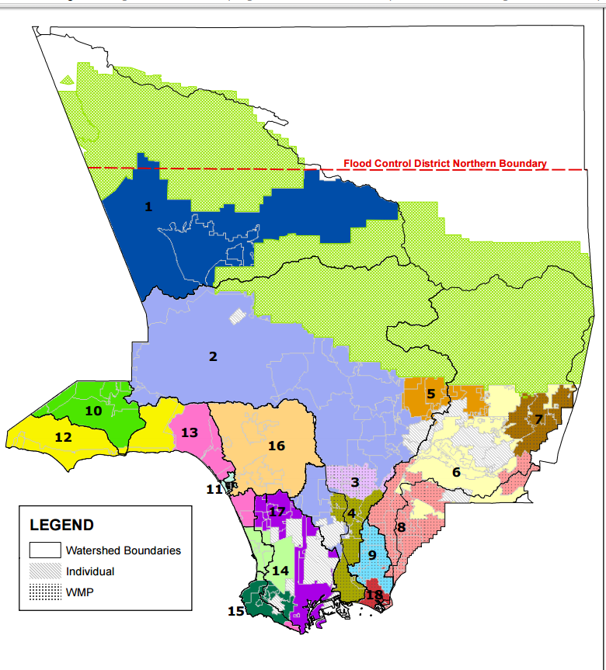

1.c. Sediment Management Strategic Plan,

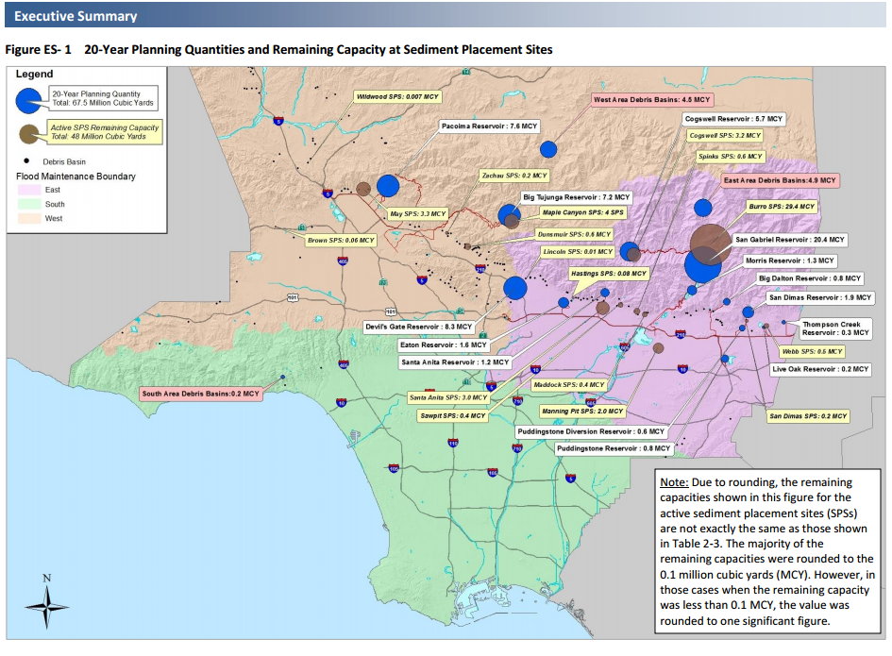

1.d. LACDA

e. City of Los Angeles Stormwater Capture Master Plan (SCMP)

2. a. Los Angeles Basin Study

2.b.1 WDR Earth Bottom

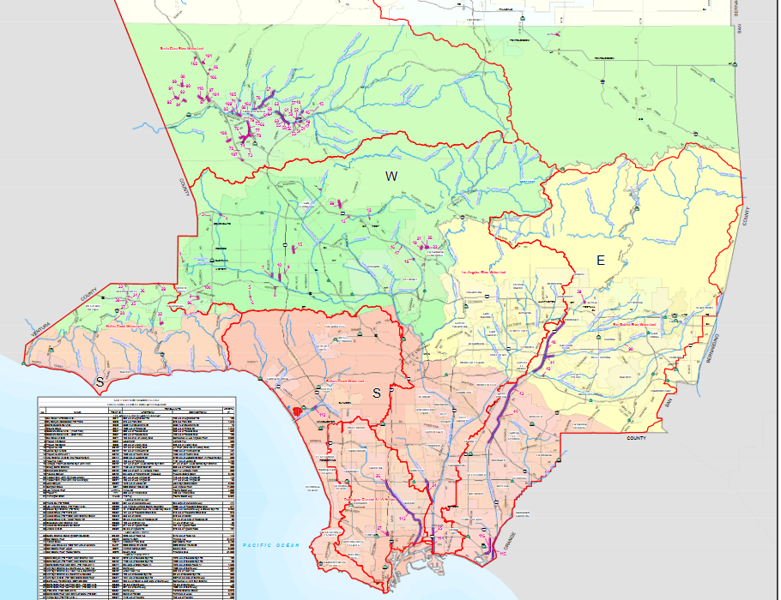

Extra text

The dredge and fill permitting program has been assessed several times in several different ways. However, these assessments did not include any analysis of cumulative hydromodification or changes to stormwater patterns.

- Assessment of the success of required mitigation in the dredge and fill permitting program in the Los Angeles Region and California include “An evaluation of the Compensatory Mitigation Projects Permitted Under Clean Water Act Section 401 by the Los Angeles Regional Water Quality Control Board, 1991-2002” (Ambrose et al., 2003) and “An Evaluation of Compensatory Mitigation Projects Permitted Under Clean Water Act Section 401 by the California State Water Resources Control Board, 1991-2002” (Ambrose 2007) http://www.waterboards.ca.gov/water_issues/programs/cwa401/docs/mitigation_finalreport_full081307.pdf. Permittees were found to be largely following their permit conditions, however, required compensatory mitigation projects seldom resulted in wetlands in optimal condition.

- Assessment of the administration of the dredge and fill permitting program in California includes an audit of the State’s Clean Water Act Section 401 program conducted by the Bureau of State Audits in 2012 focusing on 401 certifications for Caltrans but also reviewing 401 practices in general (California State Audit 2012-120) https://www.auditor.ca.gov/reports/summary/2012-120.

- Assessment of the administration of the federal dredge and fill permitting program were considered by the National Research Council as they developed recommendations to support the Army Corps of Engineers’ and USEPA’s 2008 Compensatory Mitigation Rule to improve the planning development and implementation of compensatory mitigation http://www.usace.army.mil/Portals/2/docs/civilworks/regulatory/final_mitig_rule.pdf The implementation of the 2008 Mitigation Rule has recently been reviewed by the Army Corps of Engineer’s Institute for Water Resources http://www.iwr.usace.army.mil/Portals/70/docs/iwrreports/2015-R-03.pdf).

Basin Study Typically, BMPs are designed for water quality purposes and sized to retain the stormwater volume from the 85th percentile, 24-hour storm. However, for the purposes of this study, Local Stormwater Capture projects are sized for the larger 5-year storm to increase stormwater conservation, and provide a higher adaptive capacity under wet conditions

Where LID is implemented, regardless of implementation form (e.g., rain garden or permeable pavement), it was assumed to retain the 85th percentile storm, represented by a rainfall depth of 0.75 inches for the Malibu Creek, Ballona Creek, and Dominguez Channel watersheds. For modeling, it was also assumed that BMPs would drain within 3 days in these watersheds. A rainfall depth of 0.97 inches and a draw down time of 1.5 days was assumed for the Los Angeles River and San Gabriel River watersheds. T

The Local Stormwater Capture concepts surface infiltration basins or underground infiltration chambers are sized to contain the 5-year storm, which is a larger storm than the other Local Solution projects. However, Local Stormwater Capture concepts are not as widespread through the Basin Study Watersheds because of constrained site conditions. They are only implemented within specific parcels that are appropriate for infiltration, which limits the overall stormwater conservation.

Other stuff, maybe could be included

Hydrology Manual Los Angeles County Deparment of Public Works January 2006 https://dpw.lacounty.gov/wrd/publication/engineering/2006_Hydrology_Manual/2006%20Hydrology%20Manual-Divided.pdf The primary purpose of this manual is to explain the steps involved in converting rainfall to runoff flow rates and volumes using Public Works’ standards. This manual contains procedures and standards developed and revised by the Water Resources Division based on historic rainfall and runoff data collected within the county.

Wetland and Riparian Mapping Within the Rivers and Mountains Conservancy Territory: A Landscape Profile wetland and riparian habitat maps within the San Gabriel and Lower Los Angeles Rivers and Mountains Conservancy (RMC) territory. SCCWRP 2006

General Plans?

a. Standard Urban Stormwater Mitigation Plan for Municipal Stormwater and Urban Runoff Management Programs in Los Angeles County

